**Platformer research**

**Continuity:** [**https://bit.ly/2FxE0p1**](https://bit.ly/2FxE0p1)

Players seemed to like that this game didn’t have time limits on the levels, this way they could go through the levels at there own pace.

However, it appears that some players thought that after a while the game became boring to play. They also found it hard to see some of the edges to where they could or couldn’t go. 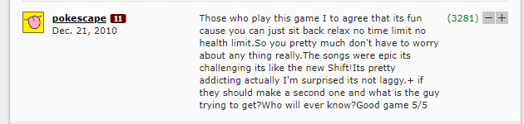





**I saw her standing there:** [**https://bit.ly/2HNK3fl**](https://bit.ly/2HNK3fl)

With this game it seemed that players liked the idea of a game with a story and they found that the music enhanced the game a lot. However, the game had a minimalistic style that meant that some players didn’t know what exactly to do.

**Fancy Pants Adventure: World 2**

Players for this game found the controls to feel sticky and unresponsive. This made the game harder to play and they some to stop playing entirely. The controls for the game were purposefully made to feel like this but the developer.

